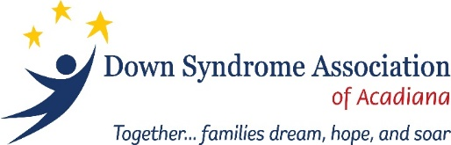
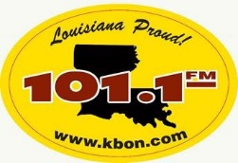
2021 - KBON 101.1 Music Festival
Sponsorship Opportunities
October 1-3, 2021 | Frog Festival Grounds, Rayne, LA

Your company is invited to be part of KBON’s Annual Music Festival!
KBON has partnered with Down Syndrome Association of Acadiana to host another spectacular fan appreciation festival. This 3-day weekend event features over 20 local bands including the areas favorite Cajun, Zydeco, Swamp Pop and French musicians. This highly anticipated event attracts over 5,000 festival-goers each year.
By becoming a sponsor, you will help DSAA continue its efforts with initiatives to empower families and people with Down syndrome in Acadiana and throughout the State of Louisiana, through information, education, and social activities. Thank you for your consideration.

About Down Syndrome Association of Acadiana
The mission of the Down Syndrome Association of Acadiana, a non-profit organization, is to provide information, advocacy and support concerning all aspects of life for individuals with Down syndrome, their families, and our community.
1. Complete the contact information.  2. Specify sponsorship level.  3. Return this form and email your logo in .jpg format.  4. Must be received by September 10, 2021. | Make check payable and mail to:  Down Syndrome Association of Acadiana or DSAA  P.O. Box 81323  Lafayette, Louisiana 70598
Contact Name: |  | Date:
Company:
Address:
City: | State: | Zip:
Phone: | E-Mail:
□ Gold Sponsor ($2,000.00):  • Recognition on sponsor banner at entrance gate  • VIP Parking - 2 vehicles per day (Friday, Saturday and Sunday)  • VIP Seating  • 6 armbands per day (Friday, Saturday and Sunday)  • 50 beverage tickets  ● Logo and sponsor recognition on DSAA website and social media | □ Silver Sponsor ($1,000.00):  • Recognition on sponsor banner at entrance gate  • VIP Parking – 1 vehicle per day (Friday, Saturday and Sunday)  • VIP Seating  • 4 armbands per day (Friday, Saturday and Sunday)  • 25 beverage tickets  ● Logo and sponsor recognition on DSAA website and social media
□ Bronze Sponsor ($500.00):  • Recognition on sponsor banner at entrance gate  • VIP Seating  • 2 armbands per day (Friday, Saturday and Sunday)  • 20 beverage tickets  ● Logo and sponsor recognition on DSAA website and social media | THANK YOU FOR YOUR SPONSORSHIP!
Your donation is tax-deductible. DSAA is a non-profit 501(c)3 organization.
Send your high quality logo (if applicable) via e-mail to smidkiff@dsaa.info as soon as your sponsorship is submitted.

Down Syndrome Association of Acadiana | P.O. Box 81323 Lafayette, Louisiana 70598 |337-234-3109 |www.dsaa.info

